**Employee Management System**

1. **Overview**
   1. **What:**

* Employee Management System is an application that manages employee data within an organization, including details about employees, departments (e.g., Operations, IT, Accounting, Finance, Admin, HR), attendance, and payroll.
* It provides features such as viewing employee details, viewing and handling attendance details, viewing and handling leave details (e.g., apply leaves, assign leave application to the respective manager, approve leaves), on-boarding (adding new employees), off-boarding (removing resigned employees), updating personal details (e.g., contact number, address, blood group), and updating job-specific details (e.g., employee ID, role, salary, department, tenure, skillset, KPIs handled, performance scores).
* The application uses MySQL as the DBMS.
* This is a web-based application that runs on a browser and is accessible within the Local Area Network (LAN) of the organization.
  1. **Why:**
* This application is useful for any organization (e.g., IT & ITES companies, banks, insurance companies, restaurants, warehouses) with employees driving the business.
* It can be used to sort and filter employees based on performance scores and provide yearly salary hikes and promotions based on the budget.
  1. **How:**
* Backend: MySQL, SQL and Python
* Frontend: Streamlit

1. **Database Structure**

**EMS**

**Employee**

Emp_ID (Primary_Key)

Emp_Name

Dept_ID

Role_ID

Contact_No

Email

Address

Date_of_Birth

Gender

Emergency_Contact

Joining_Date

Manager_ID

**Department**

Dept_ID (Primary_Key)

Dept_Name

Manager_ID

**Roles**

Role_ID (Primary_Key)

Role_Name

Role_Desc

**Attendance**

Att_Date

Emp_ID

Attendance_Status

**Leaves**

Leave_Date

Emp_ID

Approver_ID

Approver_Role

Approval_Status

**Payroll**

Emp_ID

Month_Year

Salary

Deductions

Net_Pay

**Performance**

Financial_Year

Emp_ID

Number_Of_Projects

Score

**Projects**

Project_ID (Primary_Key)

Project_Name

Start_Date

End_Date

Dept_ID

Manager_ID

**Employee_Project**

Emp_ID

Project_ID

Role_in_Project

Hours_Spent

1. **Features and Roles**

**Employee (common to all):**

Mark attendance

View attendance status

Mark leave

View individual leaves

View performance details

View projects

**Human Resource Management:**

View employee

Add Employee

Delete Employee

Update details of the employee

Add payroll for new employee

Update payroll for employee

Add payroll for the month

Generate performance data and update details

**Department Head:**

Update role

Change department

Update manager

Add roles

**Manager:**

View leaves

View approval request

**Project Manager:**

Add project

Update project details

Add or update employee project

1. **Screenshot of MySQL workbench, all the SQL commands and tables.**
   1. Employee table:

* 1. Department table:

* 1. Roles table:

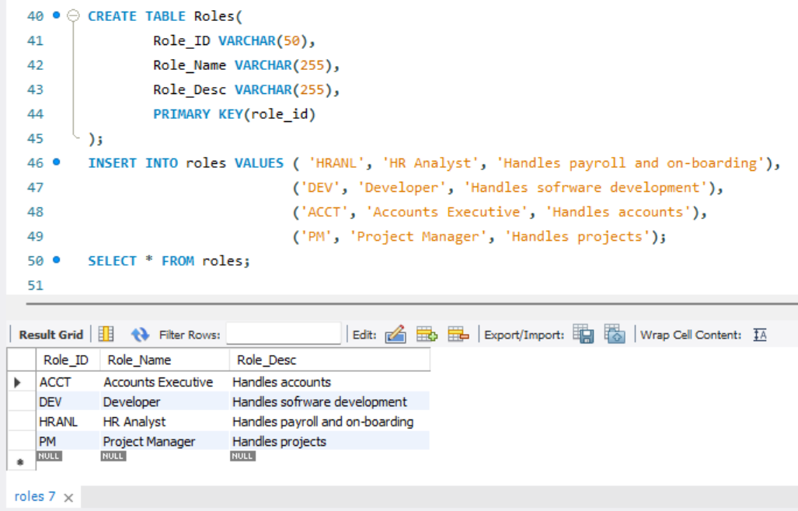

* 1. Attendance table:

* 1. Leaves table:

* 1. Payroll table:

* 1. Performance table:

* 1. Projects table:

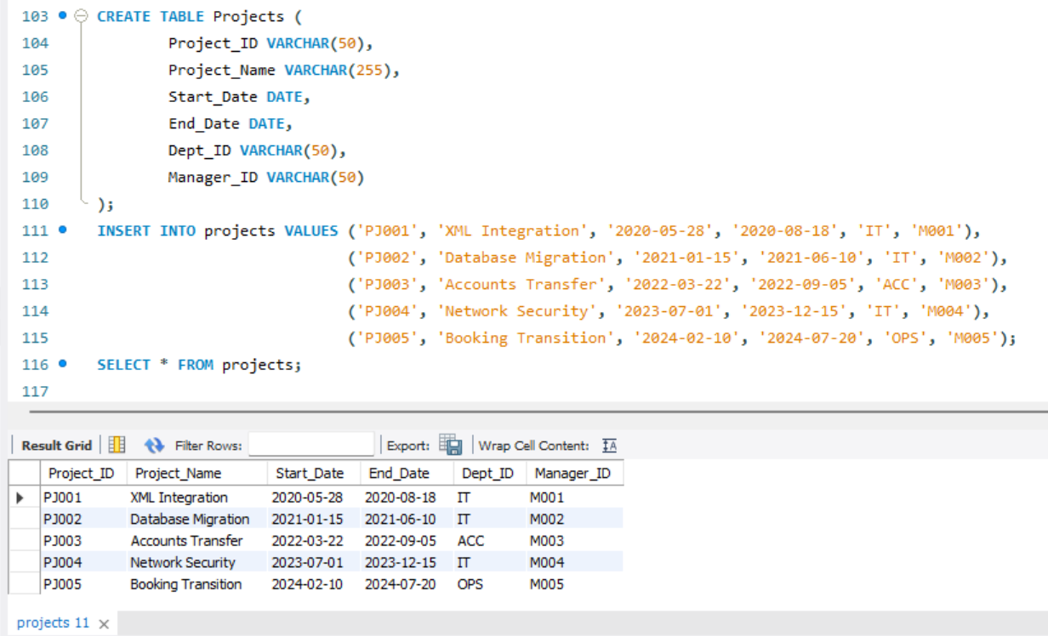

* 1. Employee_Project table:

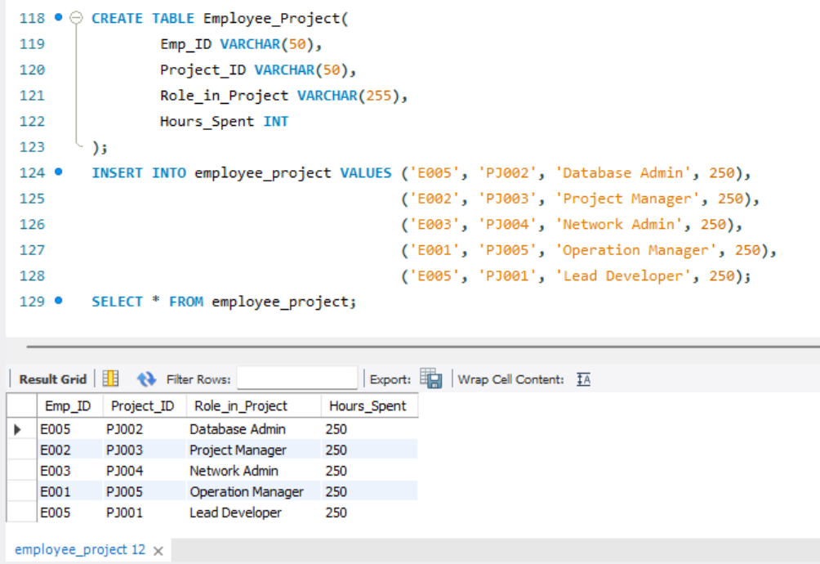

1. **Main streamlit python code**
2. **Screenshot of streamlit application including all the features**